Claire Lorts, project 2 research
SM prototype idea:
- Name ideas: Open Table, StirredUp, Mixing Bowl, Creative Table, Creative Spoon.
- Posted recipes are drafts and ideas, not being posted for a rating. This is for people who are stumped in their recipe creation or would like to improve upon an existing recipe. It’s also for people who contribute to recipe building and improvement.
- No ratings. Instead, posts for feedback and further ideas how to improve the recipe.
- No private messages. Instead, private messages can only be between collaborators (see below).
- Filter options (course, ethnicity, dietary restrictions, experimental (non-traditional), etc.).
Recipe Poster:
- Posts their draft recipe with the written recipe, a short paragraph about the recipe/why they came up with it/history, and up to 10 pictures but the first picture must be the current final product. The picture and recipe will be visible when viewers are scrolling, and viewers can click on the picture or recipe to see other pictures (lightbox?).
- Maybe posters can get badges for the amount of posted recipes in addition to contributions to other recipes.
- Posters can also find other recipes that are similar to theirs and request to collaborate on the recipe with the other poster.
- Posters can share with others (invite to collaborate or comment).
Viewer/commenter:
- Viewers must make the recipe (honors system…) to comment.
- Clicks existing button categories to make suggestions. For instance, a texture button can be clicked to suggest a different texture and how to execute the change. Then, the poster will see a small number on the button to indicate the number of suggestions (it’ll have a different color if the poster has not viewed the suggestion).
  - Buttons: flavor, texture, major ingredients, acidity, salt/pepper, sweetness/bitterness, complexity, other, etc. There could also be a button to suggest a new recipe if more than one thing (button) is insufficient.
- Using the suggestions, the poster can then update the recipe (posted as version 2, with version 1 still being accessible but not the focus).
- Viewers can follow and share recipes and people.

Similar platforms:
- All Recipes
  - Allrecipes.com
  - Has comments, ratings, featured “tweaks” to the recipe.
  - You can submit recipes, but there is no login
  - When you click on a recipe, the page has the picture at top with rating and title, followed by recipe, questions from viewers, reviews stars, featured tweaks, and written reviews (in order top to bottom). This is similar to a lot of recipe platforms.
  - Homepage has a top panel, followed by featured recipes (one large one), then different sections are you scroll (with different layouts) such as trending, valentines day recipes, seasonal picks, holidays, then some blogs, etc. The bottom footer repeats the header nav along with things like contact, careers, sm icons, etc.
  - Top panel:

- Spillt
  - https://www.spillt.co/
  - Users can save and organize recipes from anywhere online, and follow others’ saved recipe collections on the platform. People can make comments and create/follow blogs.
  - The homepage is simple with a grid system of recipe pictures that are being saved the most by users.
  - Header:
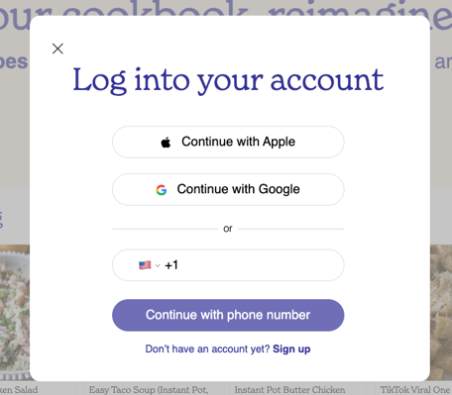
  - Login:
- Behance:
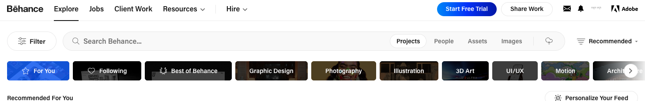
  - Header:
  - Homepage under heading is similar to spillt in that it’s a grid system of images as your scroll. There are also like icons and viewer icons.
  - Clicking on an image goes to the full project. You can save, share, find more like this, follow, comment at the bottom. There are also appreciate buttons instead of likes.

Similarities on desktop across platforms:
- Use of grid system for images on homepage, using square images.
- Limited color palette, maybe since there are a lot of colors in imagery. All three use blue gray black, and all recipes also has orange.
- All focus on the food / artwork images when scrolling. Clear hierarchy is important since scrolling /viewing is quick.
- Mobile: All similar with a similar hamburger menu (on the top left, not top right), logo, and login, followed by scrolling list of single images – square- that take up the width of the screen.

